M02 Analyzing Insertion and Selection Sort
Step 1: Run and Record
- Run your program for n = 10, 100, 1000.
Fill in the number of comparisons for each case:
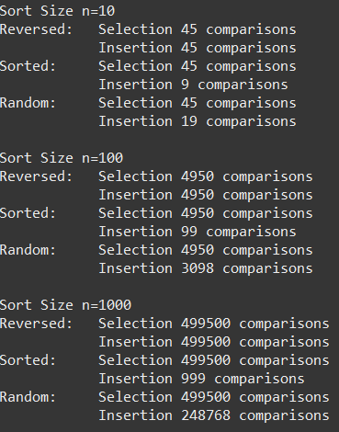
Step 2: Compare with Selection Sort
- Which algorithm always has about the same number of comparisons, no matter how the array starts? Why?
The selection sort always has the same number of comparisons. Selection sorting always compares every item in an array, and then again in the sub-array. So for a given array size, regardless of how it’s sorted, selection always makes the same number of comparisons in total.
- Which algorithm sometimes does much better? When?
Insertion sorting does significantly better with pre-sorted arrays, and better with randomized arrays.
Step 3: Reason About Best and Worst Cases
- Why does insertion sort only need ~n comparisons when the array is already sorted?
Only needs to make one comparison.
- Why does insertion sort do about the same number of comparisons as selection sort when the array is reversed?
This is the worst-case scenario: insertion sort will have to compare the next number to more number with each step.
- For random arrays, why do you think insertion sort usually does fewer comparisons than selection sort?
A randomized array can be partially sorted. This makes sense – there is only one scenario where some random set of data is the worst case (reverse sort), so any other arrangement of the data in an array will be a better case.
Step 4: Connecting to Big-O
- Both algorithms are O(n²) in the worst case. So why would we prefer insertion sort in practice sometimes?
- How does insertion sort’s best case Big-O differ from selection sort’s?
Step 5: Reflection / Extension
- If you knew your data was “almost sorted,” which algorithm would you choose and why?
- When might selection sort still be a reasonable choice?

